s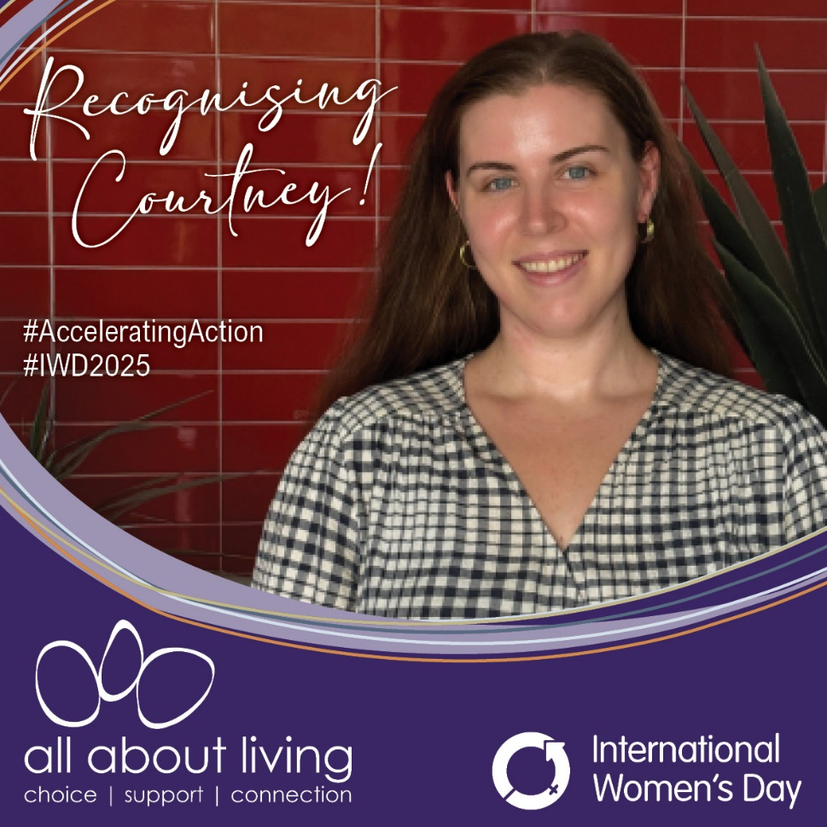

Website Article:
Recognising Courtney’s Role in Accelerating Action
Courtney Boyd, All About Living’s Digital Optimisation Business Partner, is an exceptional role model for women in the IT industry. This year’s International Women’s Day theme is "Accelerating Action," and Courtney exemplifies the commitment and actions needed to help close the gender gap. Her journey is one of dedication, resilience, and a relentless drive to challenge boundaries, inspiring those around her.
When talking to Courtney about her achievements, she shared that one of the challenges she faced early in her career was getting her voice heard. Not just as a woman but also as a young person in the industry. “Being respected, particularly for my opinion, was difficult,” she shares. But Courtney didn’t let this hold her back. She made the most of the opportunities that came her way. Starting in an entry-level support role, mostly answering the phone, she took the initiative to take on more responsibilities, resolving issues before they got escalated and proposing ideas to streamline processes. Through this, Courtney earned her place in bigger discussions. Her willingness to take risks and put herself forward has been key to her success.
At All About Living, Courtney has found a supportive environment that truly values trust and autonomy. "AAL trusted me with projects, allowing me the freedom to manage them as I chose, fully confident in my ability to do the job. That was refreshing." she says. This sense of empowerment has been crucial to Courtney’s ongoing success.
Despite her achievements, Courtney acknowledges that women in IT still face obstacles. While things are slowly changing, breaking into higher positions remains a challenge. She’s passionate about increasing diversity in the workplace and encourages women to push themselves further. “Diverse teams lead to stronger, more innovative outcomes,” she believes.
Courtney’s advice to young women looking to break into male-dominated fields? “Be the best that you can be. Set your goals and don’t stop working until you reach them.” Courtney’s journey is proof that with perseverance, support, and a willingness to take risks, women can break through barriers and create lasting change.
We’re proud to have Courtney as part of our team and grateful for the way she’s paving the way for future generations of women in IT.

Staff Newsletter Article
Recognising Courtney’s Role in Accelerating Action
This International Women’s Day, we want to take a moment to recognise Courtney Boyd, our incredible Digital Optimisation Business Partner. Courtney’s journey in the IT industry is a true reflection of dedication, resilience, and challenging boundaries—and she’s an inspiration to all of us.
Courtney faced challenges early in her career, not just as a woman, but also as a young person in the industry. She shares that, “Being respected, particularly for my opinion, was difficult,” but she didn’t let that stop her. Starting in an entry-level support role, Courtney took every opportunity to step up, offering solutions and sharing ideas. Her hard work and willingness to take risks have helped her earn a seat at the table and achieve success.
At All About Living, Courtney has always felt empowered and supported. She appreciates the trust we’ve placed in her to lead projects and take on new challenges. But, like many women in IT, she acknowledges there’s still work to be done. Courtney encourages women to keep pushing themselves and believes that diverse teams are stronger and more innovative.
We’re proud to have Courtney with us and grateful for everything she does to inspire others every day.

Social Media Post

Instagram & Facebook
🌟 Celebrating Courtney: A Champion for Women in IT at All About Living 🌟
This International Women's Day, we’re proud to recognise Courtney Boyd, our Digital Optimisation Business Partner. Courtney’s journey in IT is a testament to resilience, dedication, and pushing boundaries.
Read more about her story and how she’s inspiring future generations of women in IT. 💻✨
👉 [Link to Full Article]
#IWD2025 #AcceleratingAction #AllAboutLiving

Linkedin
This International Women's Day, we are proud to recognise Courtney Boyd, All About Living’s Digital Optimisation Business Partner. Courtney’s journey in the IT industry reflects the theme of "Accelerating Action," as she continues to challenge boundaries, drive innovation, and inspire others.
Her dedication and willingness to take risks have been integral to her success, and she is a strong advocate for diversity and empowering women in the workplace.
Read more about Courtney’s inspiring journey and her impact on the IT industry.
👉 [Link to Full Article]
#IWD2025 #AcceleratingAction #AllAboutLiving

